**RSS Stack Sheet Explained**

Pre-Production assembly tolerance stack-up analysis is necessary to understand weather parts within the assembly will function as per design intent.

Worst Case stack-up analysis is predicated on the probability that all parts within the assembly could be produced at the extreme limits of their specified tolerances.

**W.C. Example:**

OBJECTIVE

E

D

C

B

D

B

C

A

E

A

A = 10 ±0.5

B = -9 ±0.45

C = 8 ±0.4

D = -7 ±0.35

E = 6 ±0.3

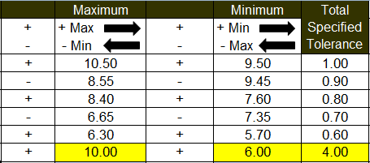

OBJ

Though the worst case method is simple to perform, it is most suitable when small numbers of components are in the assembly. We will investigate probabilities of small numbers vs. large numbers later in this document.

RSS Stack-ups require "ST" be applied to ALL dimensions within the Stack. Choosing to use RSS on Stack-ups where dimensions are without "ST" runs the risk of part tolerances being outside ±3σ.

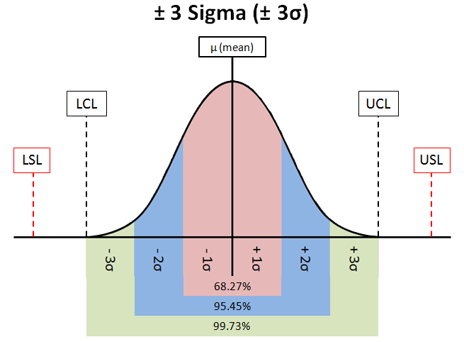

**Statistical Tolerance** - is the assigning of tolerances to related components of an assembly on the basis of sound statistics (such as the assembly tolerance is equal to the square root of the sum of the squares of the individual tolerances). By applying statistical tolerancing, tolerances of individual components may be increased or clearances between mating parts may be reduced. The increased tolerance or improved fit may reduce manufacturing cost or improve the product's performance, but shall only be employed where the appropriate statistical process control will be used. Therefore, consideration should be given to specifying the required Cp and /or Cpk or other process performance indices.

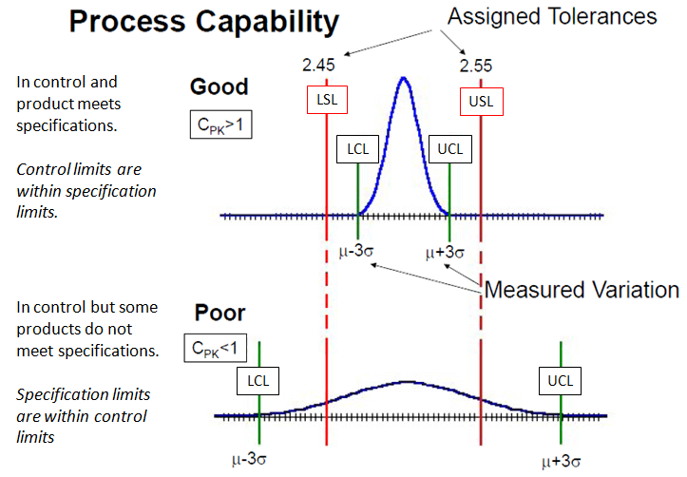

Pre-Production assembly stack-up analysis is done during the design/development stage in the Engineering Department.

* At this stage, there may be no previous statistical process control data available from the parts supplier/manufacturing for which to base a Cp and/or Cpk factor. Also, during this stage, we must assume the process is centered about the mean (nominal) values specified per the design.
* However, you may be fortunate enough to be working with parts suppliers or manufacturing who have a proven track record and can provide all the necessary SPC (Statistical Process Control) data for you to base your RSS stack-up analysis.
* To have confidence in your RSS (Root-Sum-Squared) stack-up analysis, you must put faith in the parts suppliers or manufacturing to perform ethically and honestly in their SPC reporting. Most OEMs have a Supplier Quality Assurance (SQA) team who monitor and assist their suppliers to ensure the SPC is done correctly.
* If you have any doubts as to the parts suppliers or manufacturing meeting these requirements, it falls on you, the responsible engineer to fulfill your due diligence, by requesting all pertinent documentation necessary for an accurate RSS stack-up analysis and to escalate any non-conformance to your management.

**RSS Example:**

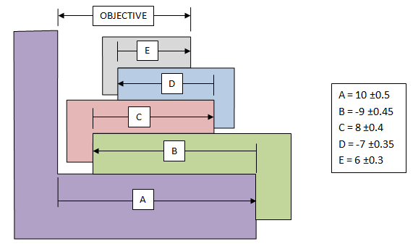

Add up the five blocks to get μ (mean),

Σ (10-9+8-7+6) = 8.0 = μ

Take the square root of the sum of the squares of the standard deviation of the tolerances, which looks like this...

σ

σ

1. (±0.50/3)2 = 0.0278 Or (1.0/6)2 = 0.0278
2. (±0.45/3)2 = 0.0225 Or (0.9/6)2 = 0.0225
3. (±0.40/3)2 = 0.0178 Or (0.8/6)2 = 0.0178
4. (±0.35/3)2 = 0.0136 Or (0.7/6)2 = 0.0136
5. (±0.30/3)2 = 0.0100 Or (0.6/6)2 = 0.0100

... (divide by 3 because you are assuming that your tolerances represent ±3 standard deviations or divide the total tolerance by 6)

Sum the squares…

$$\sum_{i=1}^{n}{{\left(σ_{i}\right)}^{2}}+{\left(σ_{i+1}\right)}^{2}= 0.0917$$

Take the square root of the sum…

$\sqrt{0.0917}=0.3028$ = 1σ

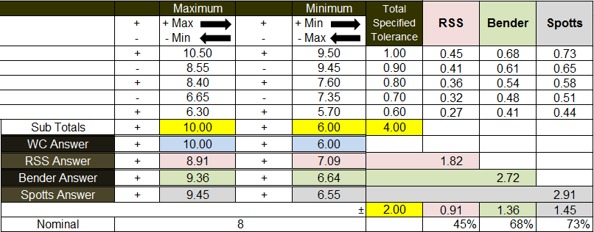



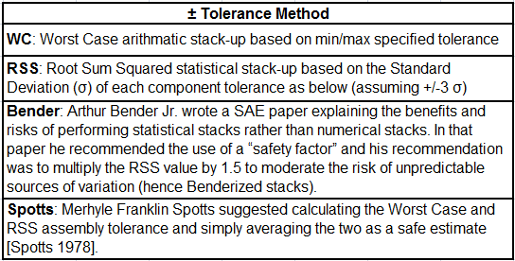

To understand the **RSS** tolerance value:

* If 1σ = .3028, then ±3σ = 1.8166
* Since we are using two place decimals ±3σ = 1.82
* The sum of the RSS tolerances must equal 1.82
* The sum of the W.C. tolerances equals 4
* For each RSS tolerance: (1.8166/4)*WC tolerance

**Benderized** tolerance values seem simple enough; just multiply the RSS value by a “safety factor” of 1.5. However, you can actually end up with a larger than W.C. results if most of your tolerances happen to be small and one tolerance is large (see below):

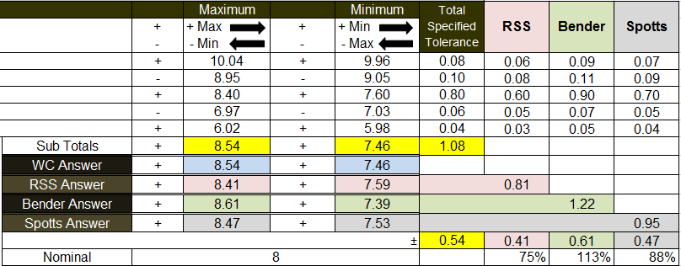

**Spotts** seems to be the safest choice for Pre-Production RSS Modified stack-up analysis. Especially if your parts suppliers or manufacturing has yet to provide proof of their process control. This would also allow for variation about the mean due to trend shifts during production.

**Probabilities of small numbers vs. large numbers assemblies.**

This Monte Carlo stack-up is based on virtual samples of an assembly with only two parts that fall anywhere between LSL & USL. This would be an example of 100% inspection **without** SPC control.

If you use 100% inspection and maintain only two parts between LSL & USL, you will see that neither RSS or SPOTTS approaches the min. goal of ±3σ (99.73%), and the Cp & Cpk are both < 1.0. Which means the LCL & UCL fall **outside** the LSL & USL (see below).

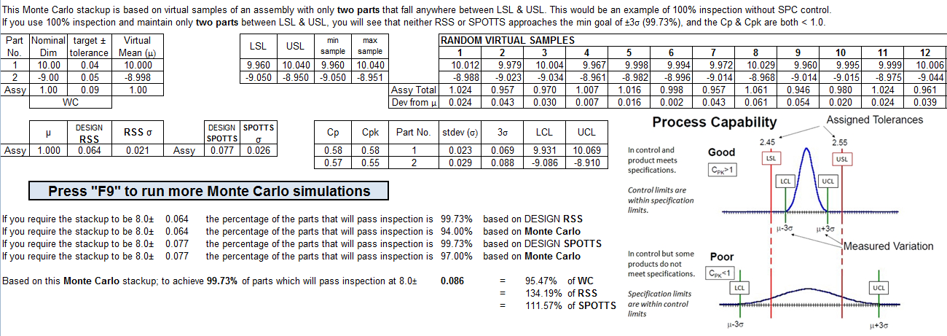

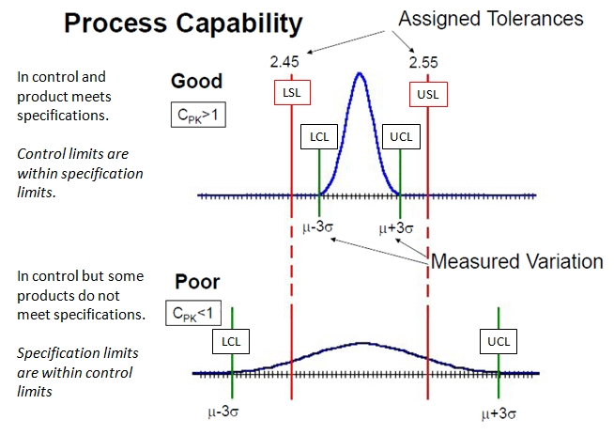

This Monte Carlo stack-up is based on virtual samples of an assembly with only two parts that fall anywhere between LCL & UCL. This would be an example random inspection **with** SPC control.

If you use SPC inspection and maintain only two parts between LCL & UCL, you will see that both RSS or SPOTTS achieve the min. goal of ±3σ (99.73%), and the Cp & Cpk are both > 1.0.

Which means the LCL & UCL fall **within** the LSL & USL (see below).

